$$Area=length × width$$
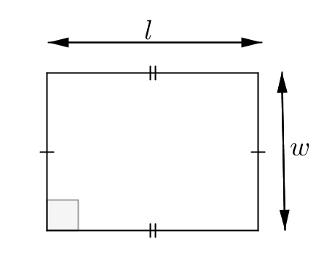

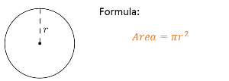
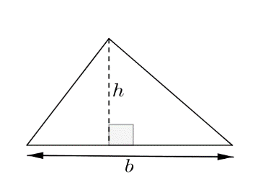
$$Area=\frac{1}{2}(base × height)$$

$$π≈3.14$$

Calculate the area of each shape:
5cm
9cm
(1) (2)
11cm
18m

12mm
14cm
11cm
8cm
19cm
(3) (4)

4km
5km
9km
15km
7m
(5) (6)

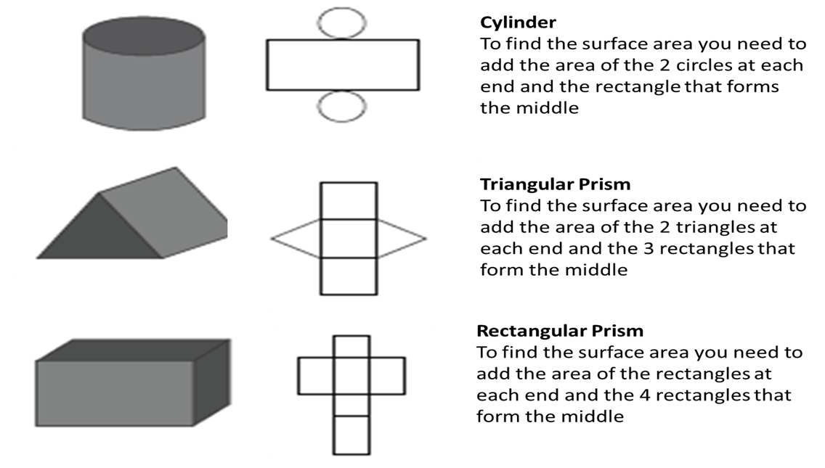
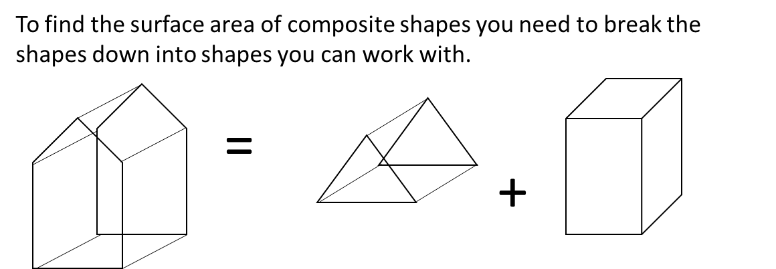
.
Find the total surface area of these shapes. Remember answers are in square units. All shapes are fully closed except where otherwise indicated.
17cm
(1) (2)
8cm
8cm
11cm
9cm
20cm
15cm

(3) (4)
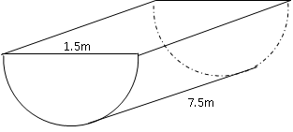
5.3m
2.8m

